**16x2 LCD Build Instructions**

**Build Instructions**

The project that I decided to work on this semester was created by using the 16x2 LCD display, to display information from any particular sensor like the BME280 sensor. This project can be built by one person and the parts that this project uses is a Raspberry Pi 3 and a 16x2 LCD display.

**Correct Web Template Used:**

When you are building this project, it is a good idea to keep track of all the progress being made, since this will take a lot of time and commitment. The best way to keep track of progress being made is by writing everything to a blog which was what I did when doing this project. We created our own website using GitHub as our starting point in order to get started. A template for a GitHub website can be found: https://github.com/sixOfour/StudentSenseHat. The way we created our GitHub was by cloning the repository and then working with the index.md or the indexcontent.html file.

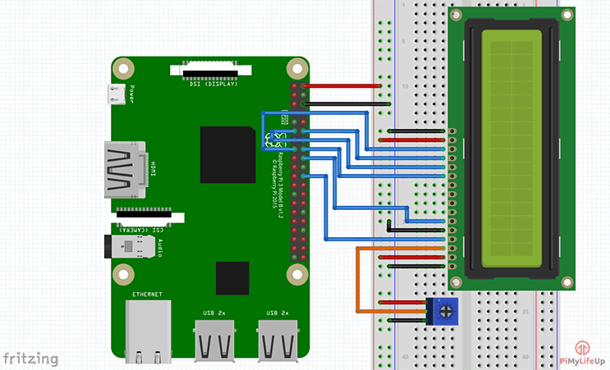

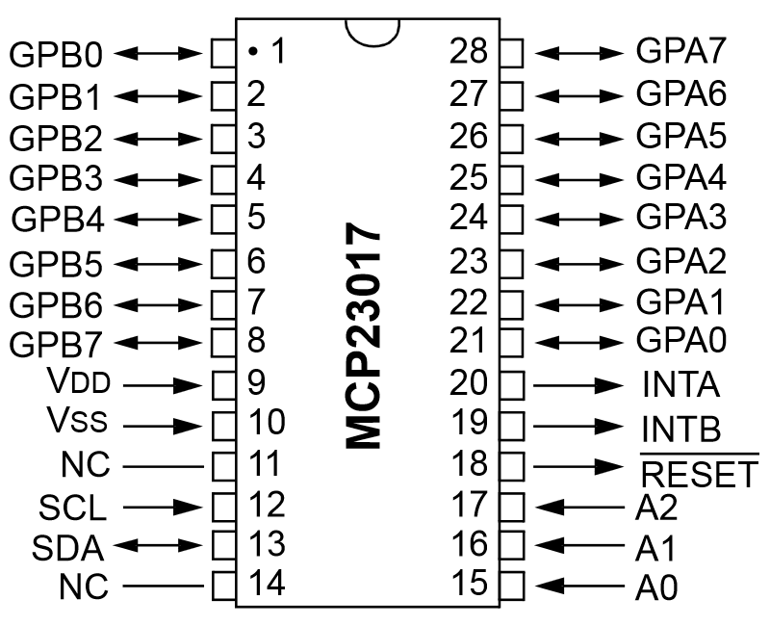

**Bill of Materials/Budget:**

1x Raspberry Pi 3 starter kit – $99.99

1x 16x2 LCD - $23.87

These parts were purchased off of Amazon.

**Time Commitment:**

This project took me longer than expected to complete. There was a lot of time and commitment put in to achieve the end result. There was a lot of research required. I started off by researching the parts I would need in order to make this project. Next, I had to research how to connect the 16x2 LCD display with the Raspberry Pi. Then, I researched the code needed for the 16x2 LCD to display information typed by the user. Next, I had to research the schematic of the MCP23017 chip so that I could make sure my 16x2 LCD had the same connections as the schematic did. Once I did that, then I had to make any necessary changes if the connections were not the same. Finally, I had to research and figure out what GPIO pin the Pi was using to output the message onto the 16x2 LCD display. Then it took me a couple of weeks to put the whole project together. Overall, the time and commitment that I put into this project was enough in order for me to finish and achieve the end result of this project.

**Mechanical Assembly:**

1. First, you will need to solder a PCB board together by sending the Gerber files to the prototype lab so that they can make the board for you.
2. Once you have the PCB board, you will need to follow the instructions provided to you when you click on this click: https://six0four.github.io/StudentSenseHat/. This link will guide you step by step on how to solder all the parts that come with the PCB board.
3. Once you are in the process of completely soldering your PCB board you can then purchase the 16x2 LCD display.
4. Once you get the 16x2 LCD display, you may need to solder the header pins if they aren’t already soldered for you. In this case, my 16x2 LCD display came with everything already soldered.
5. Once the header pins are soldered, u can now use your 16x2 LCD display.
6. Next, you need to test the connections on the 16x2 LCD by looking at the MCP23017 chip on the LCD using the schematic provided above to make sure that the connections for your LCD display are the same as the schematic.
7. Then, you will need to make sure that you have made the necessary changes to the pins if they are not the same connections as the schematic above.
8. Once you have done that, you will need to make sure that you have the right output pin that is needed to show the message that you are trying to display on the 16x2 LCD. In this case, I had to use RGPIO output pin 22 to be able to display the message.
9. Then, you can go to this link: <https://github.com/adriancaprini/BluetoothProjectProposal-> which is the link to my GitHub website. You should then clone and download my GitHub so you have all the documentation and code I used to create this project.
10. Finally, once you have cloned and downloaded my GitHub website, go to the char_lcd.py file and copy and paste the code inside a file that you created. The filename can be called whatever you like. When you do that make sure that if you made any changes to the pins, you reflect those changes in the code. In my case, that file shows the pins that I had to use for the 16x2 LCD, but it may not be the same for everyone.

**Soldering:**

The project which I decided to make required me to solder a PCB board together. This had to be done for two reasons: one was for me to be able to connect the BME280 sensor module and the light sensor module to the PCB board and the second reason was I needed the PCB board header pins to connect the 16x2 LCD display on, so that the PCB board and the 16x2 LCD display would be connected to the Raspberry Pi in order for me to get an output on the 16x2 LCD display.

**Power up:**

If you are booting up the Raspberry Pi for the first time, insert the SD card to the SD card reader from the Raspberry Pi package and make sure that the correct operating system is preinstalled. If it is not, the OS can be downloaded from this link: <https://www.raspberrypi.org/downloads/noobs/>. Once the OS has been installed on the Raspberry Pi, insert the SD card into the SD slot of the Raspberry Pi and power it on by plugging the power supply into an electrical outlet. After doing this, the Raspberry Pi should then boot up. Before going further, users will be required to set up the operating system and configure their Raspberry Pi settings such as internet connection. Users should also have I2C enabled in order to do this project. To enable the I2C, users will have to follow these steps:  
Start, go to Raspberry Pi configuration, then go to Interfaces and check mark the I2C enable if it hasn’t already been checkmarked.

**Unit Testing:**

In order for us to test if the 16x2 LCD display is connected properly and the Raspberry Pi is reading the BME280 and the light sensor modules properly, we need to type a command that will show us a list of addresses and if anything is connected to them. To do this open up a terminal and enter: “sudo i2cdetect -y 1”. Once the command is issued it will show an output of multiple addresses and in my case, we should see that our 16x2 LCD display is connected at address 20. Then we will test the sensor by creating a python code file that can be called anything you want like firstname_lcd.py. The code that you put in that file can be found on my GitHub website which I called char_lcd.py. Save the python file you just created and compile in the terminal by using “python firstname.py”. This command will compile and run the program for you if there are no errors within the file. After issuing this command, the program will execute.

**Production Testing:**

Once the program has successfully ran the output, it will display temperature and pressure values. The temperature values will change when you put your hand on the BME 280 sensor and will decrease when you take your hand off of it. The program is running in a loop so that the user doesn’t have to keep running the code to see if the temperature or pressure values change each time.

**Reproducible:**

I believe that my project is reproducible since I have provided all the necessary documents and detailed mechanical assembly instructions for someone else to build this project using the 16x2 LCD display. If you follow the instructions and use the schematic I provided above as reference, you should be able to recreate it. I have also provided my GitHub and other documentation files such as my budget, the necessary parts used to build this project, detailed instructions, the correct code and instructions on how to run the code.